**LAB # 09**



**CSE301L Signals & Systems Lab**

Submitted by: **Maaz Habib**

Registration No: **20PWCSE1952**

Class Section: **C**

“On my honor, as a student of University of Engineering and Technology, I have neither given nor received unauthorized assistance on this academic work.”

Student Signature: ______________

Submitted to: **Engr. Durr-e-Nayab**

6/26/2022

**Department of Computer Systems Engineering**

**University of Engineering and Technology, Peshawar**

**Lab Objectives:**

Objectives of this lab are as follows:

* Power of Continuous & Discrete time Signals
* Application of Fourier Series
* Synthesis of Square Wave
* Synthesis of Triangular Wave

**Task # 1:**

Calculate the power of discrete‐time cosine signal with period 20, defined over interval 0:19 using the following formula:



**Problem Analysis:**

Choose a cosine signal and put the values in the above formula to find the power of the signal and plot the signal.

**Code and value of Px:**

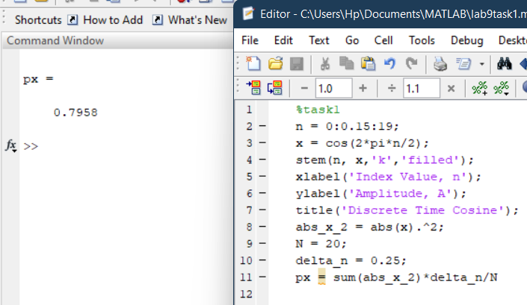

**Output:**

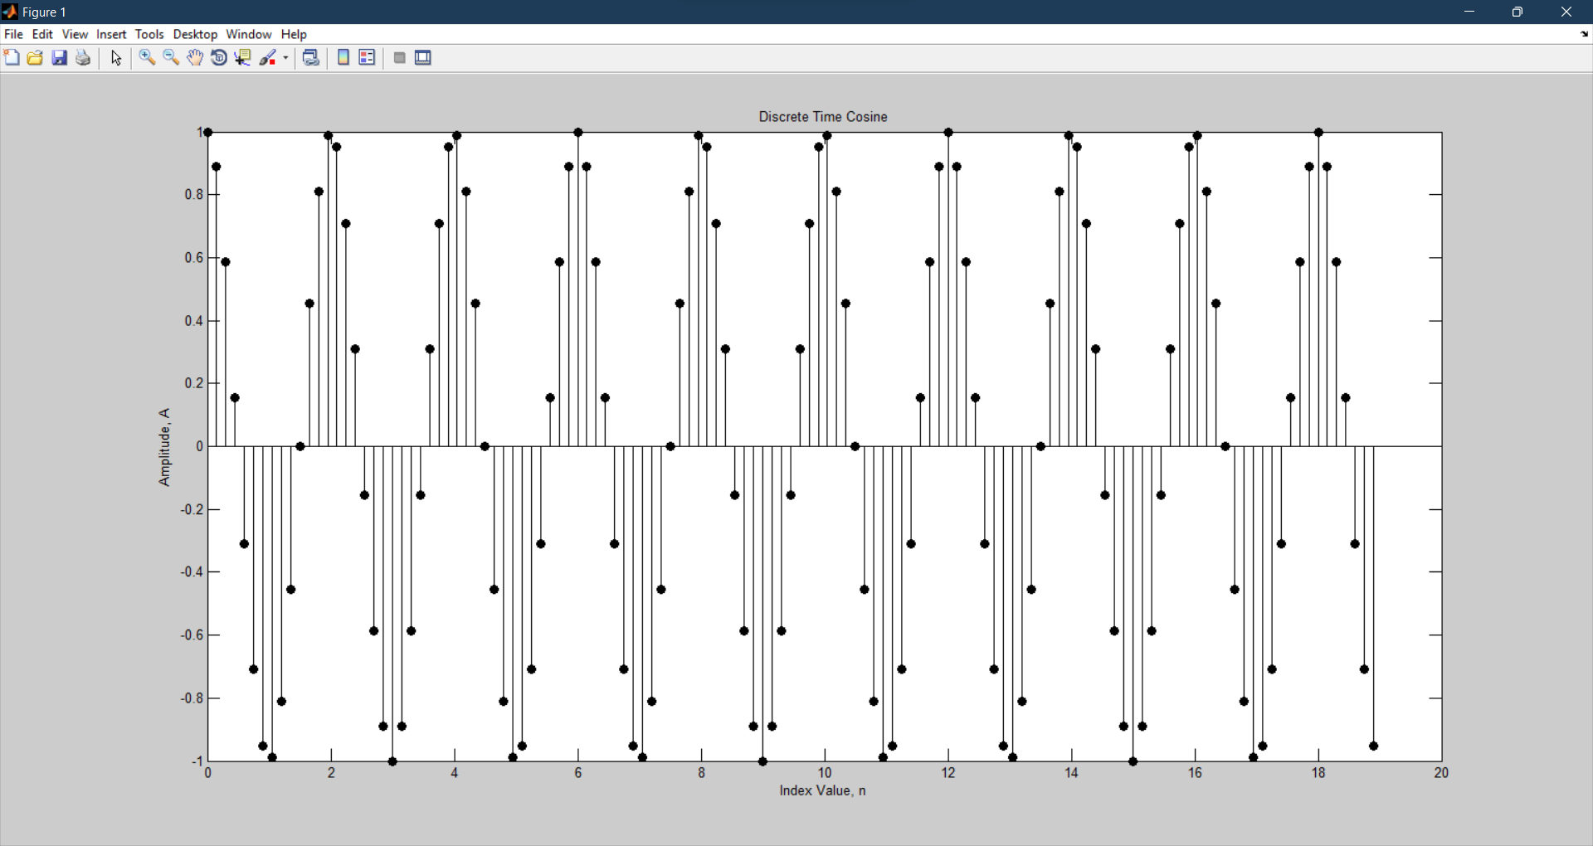

**Task # 2:**

Analyze the effect of Adding 1st to 17th harmonics and the effect of Adding 1st to 27th harmonics in above example.

**Code:**

**1st to 17th Harmonic:**

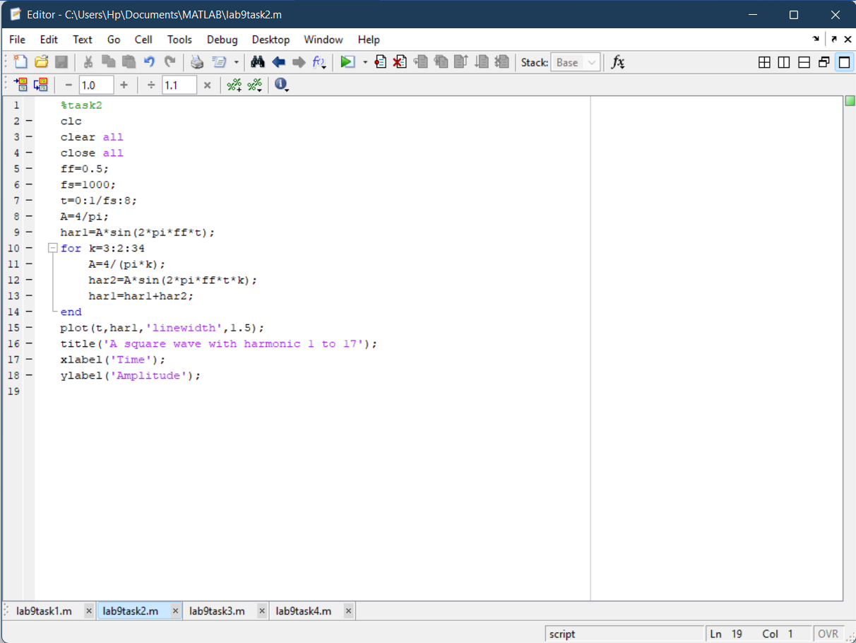

**1st to 27th Harmonic:**

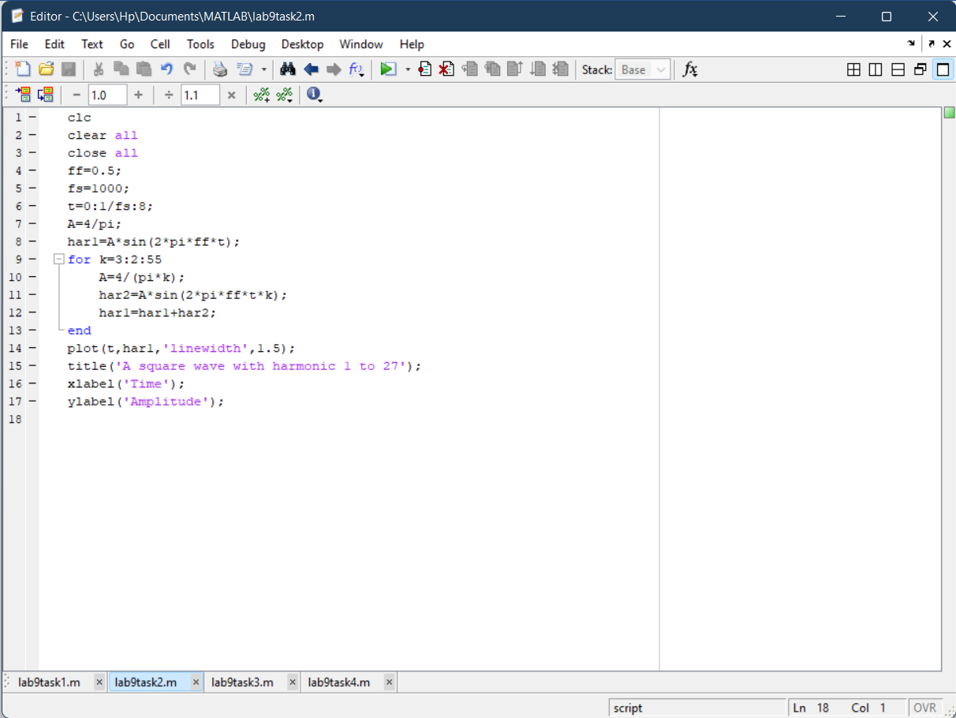

**Output:**

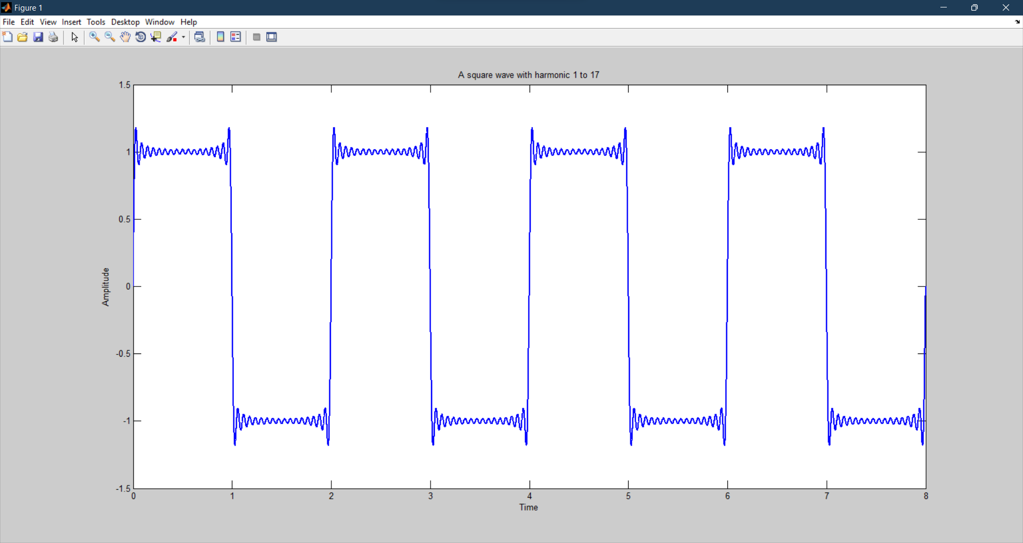

**1st to 17th Harmonic**

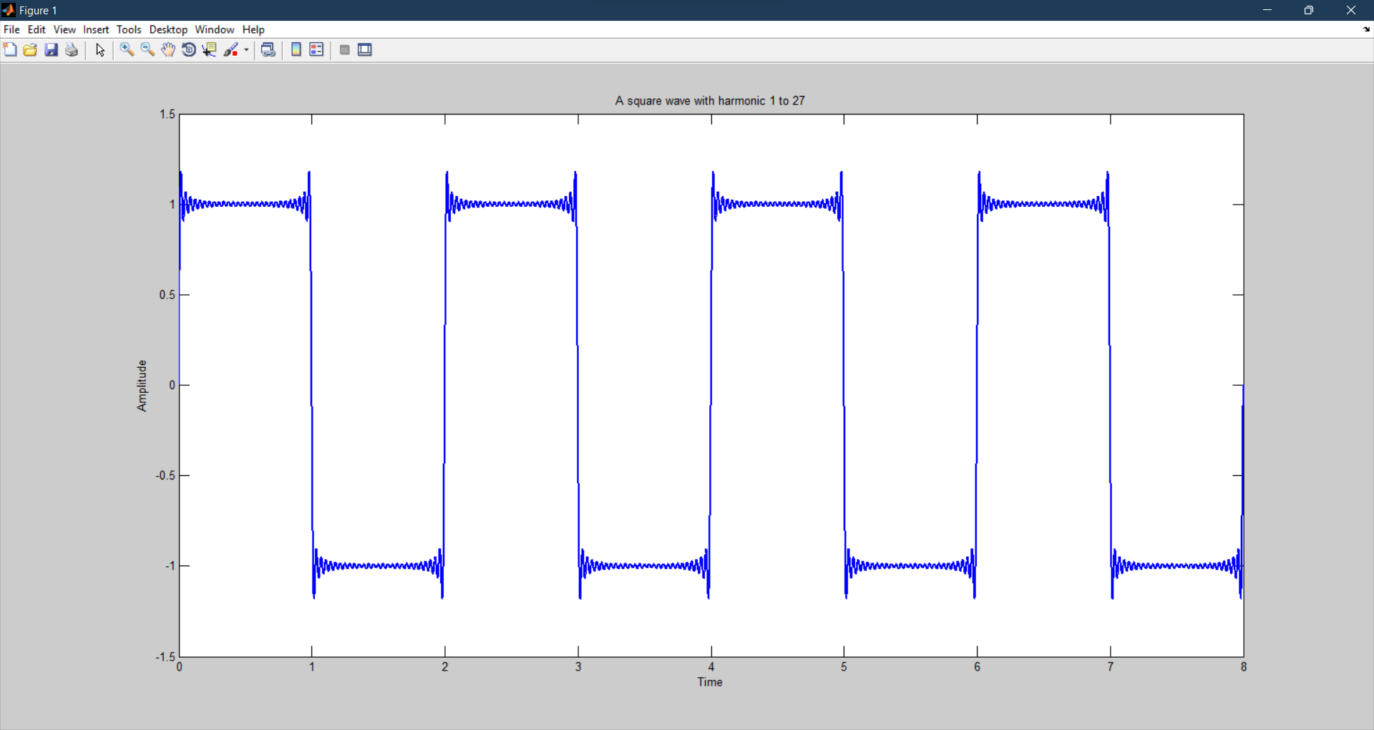

**1st to 27th Harmonic:**

**Task # 3:**

Write a program that plots the signal s(t).

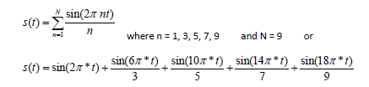

**Problem Analysis:**

Take the sum of the given sine signal for different values of n and plot the resultant signal.

**Code:**

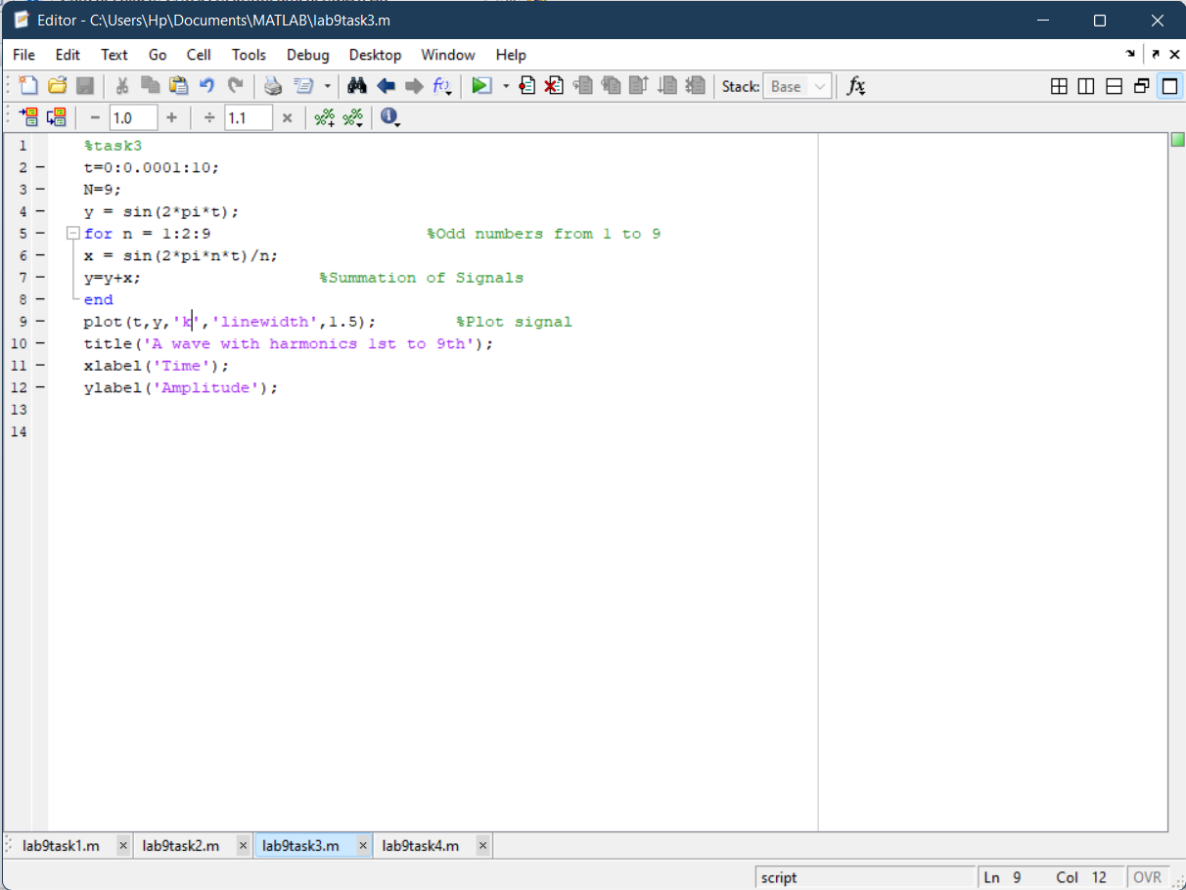

**Output:**

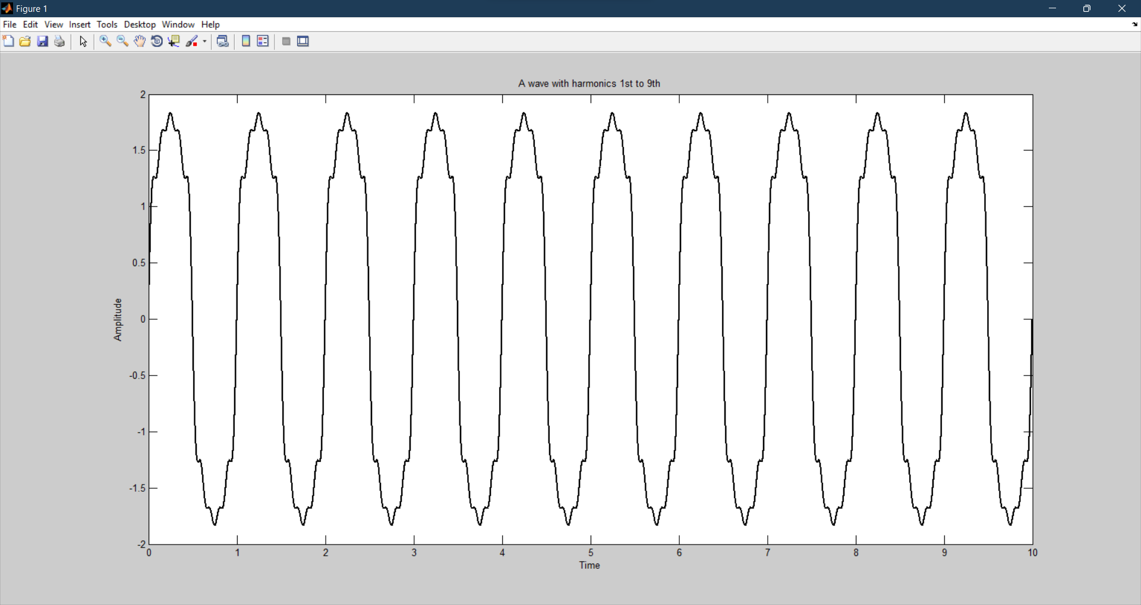

**Task # 4:**

Generate a triangular wave with N=11.

**Code:**

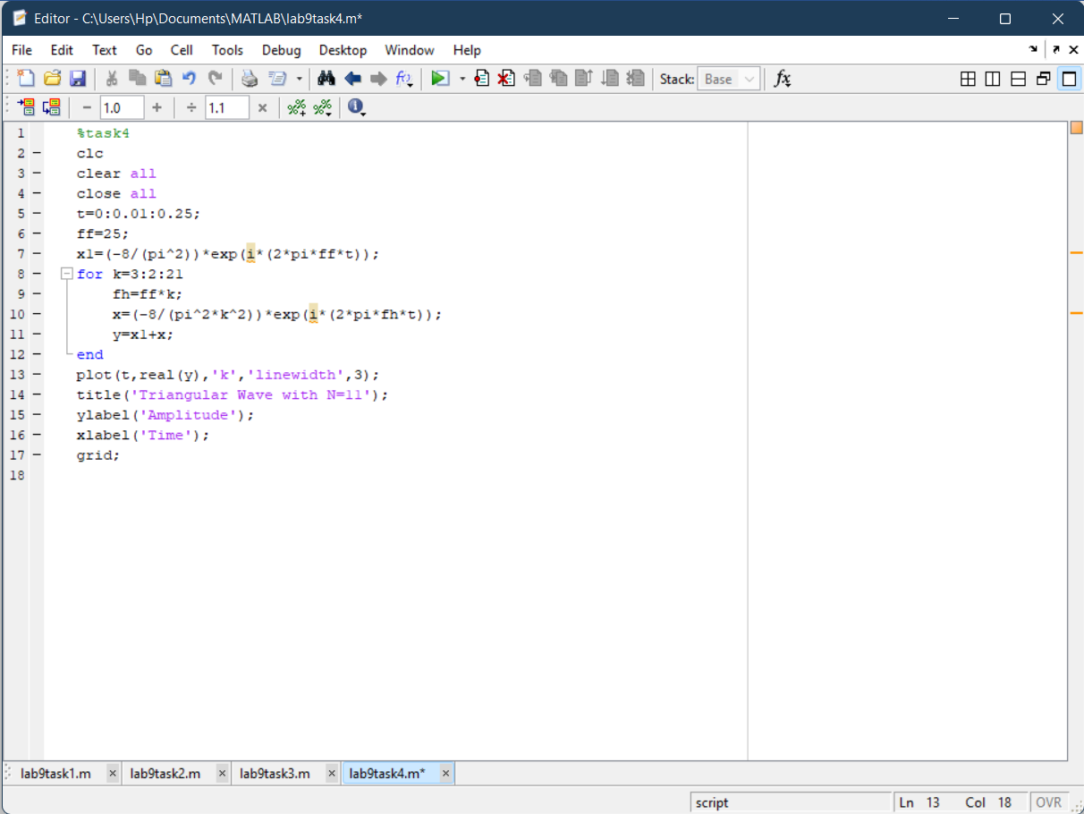

**Output:**

